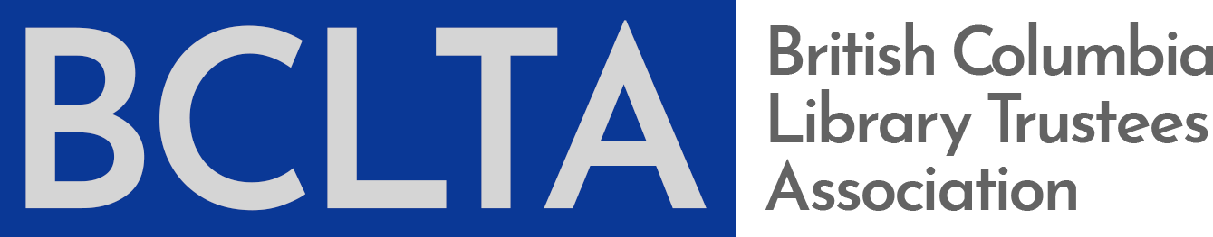

Board Discussion Starter

Diversity and Inclusivity

Trustees bring a diversity of experiences, skills, knowledge, and questions to public library board work. Board policies and practices vary across the province and BCLTA is focused on common issues of common concern for board development. Your board chair, your library director, and BCLTA all have a role in helping you find further resources specific to your needs. The Libraries Branch staff are available for all questions regarding the Library Act.

Your board inclusivity and diversity discussions might cover a wide range of topics such as:

- The broader local and library community discussions that are informing the environment of your board work.
- Public library statements, policies, strategic plans and other board level reports regarding inclusivity and diversity.
- The alignment of inclusivity and diversity with public library values such as equitable access and intellectual freedom.
- The benefits of addressing inclusivity and diversity in your board succession and recruitment planning.
- Building a shared understanding among the board and staff of “inclusivity and diversity” and what this means to the community the library serves.
- Supporting the library director so that they are successful with their day-to-day work of managing and overseeing what inclusivity and diversity means to library operations.

Resources

Government

BC Provincial Government
- An actionable priority for the government as an employer as seen in their Diversity and Inclusion Action Plan
- An example of plain language and clear objectives for developing strategic direction to address inclusivity and diversity.

Official Community Plan
- Consult your community’s OCP for value and vision statements regarding inclusivity and diversity and for opportunities for the public library to further the goals of the OCP.

Library World

Canadian Federation of Library Associations
- Position Statement on Diversity and Inclusion

BC Library Association
- Values Statement

“Sharing our words, transforming our relationships” , Open Shelf, Ontario Library Association, November 11, 2018.

“Cultural diversity and inclusion in the workplace”, Open Shelf, Ontario Library Association, September 10, 2018.

Glossary of Terms: equity diversity, inclusion from the American Library Association, 2017.

Chris Bourg, Director of Libraries at MIT, and sought after speaker on inclusivity, diversity and equitable access in librarianship and technology.
- “For the love of baby unicorns: My Code4Lib 2018 Keynote”, Feral Librarian, February 14, 2018.

Tara Robertson, Diversity & Inclusion Strategic Partner for Mozilla and respected BC librarian working, writing, and presenting on accessibility, diversity and inclusivity.
- “blah blah blah: diversity and inclusion”, November 2018.
- Keynote delivered at the National Digital Forum in Wellington, NZ that includes critical questions that need to be asked such as “who is in the room?” and “who is missing?”.
- Video via youtube.

Organizational Development

“The Path to an Inclusive and Accessible Community”, Tamarack Institute, by Heather Keam, May 2018.
- Case study of Kamloops to highlight the work municipalities are doing across Canada for developing Accessibility and Inclusion policies.

Diversity, Inclusion and Equity, Board Source, n.d.
- The role of the board in providing leadership for organizational diversity, inclusivity and equity.
- Includes links to resources and articles.

Where is Race on Your Board’s Recruitment Agenda?, Board Source, n.d.

Leadership Diversity in the Nonprofit Sector: Baby Steps, Big Strides, and Bold Stances, OnBoard Canada, June 2012.
- Evidence regarding the benefits of diversity on boards such as greater community connections and engagement and improved transparency and oversight.

“Diversity and Inclusion: What’s It All About Anyway?”, Vantage Point, by Nav Nagra, November 5, 2018.
- Brief post that highlights the nuances of diversity, inclusivity, and representation.

Canadian Centre for Diversity and Inclusion
- The centre’s vision is a “Canada without prejudice and discrimination – a country that celebrates diversity, difference and inclusion.”
- Website offers resources and learning opportunities such as webinars and conferences, a weekly blog and a Byline Articles section on topics such as gender equity in leadership, LGBTQ self-identification and the workplace and the ROI of D&I
- No-fee newsletter Diversity Ink

Popular Media and Blogs

“How do we Design Workplaces for Inclusivity and Diversity”, Forbes, July 19, 2018, by Dr. Pragya Agarwal.

“Inclusion, Exclusion, Illusion and Collusion”, Ted Talk by Dr Helen Turnbull, CEO Human Facets and inclusivity and diversity expert.
- Expert on unconscious bias and the neuro pathways that make us sympathetic and apathetic to “outside groups”.

BC Public Libraries in Action

Organizations value and assess what they state as important. The following is a small survey of BC Public library policies, reports, and other board documents regarding diversity and inclusivity:

Vancouver Public Library
- Diversity and Inclusion Statement

Greater Victoria Public Library
- Values on “About” page include Inclusiveness: We respect diversity and provide open access for all in welcoming physical and virtual spaces.

Prince George Public Library
- Strategic Plan 2016-2020 states Inclusivity as a value: The PGPL provides welcoming and respectful environments.

Chetwynd Public Library
- Strategic Plan 2018-2021 has “Openness and Inclusion” has its first stated value: We are committed to creating an environment for diverse activities and for the gathering of knowledge including issues of race and ethnicity, gender, and cross-cultural exchange. We affirm our commitment to our diverse intellectual community and to the safety of patrons and staff.

Contact BCLTA to add your resources, templates, or policies to this Discussion Starter.

